
20/10/2025
dell
Hanane Omeiri
Course outline: Occupational risk assessment (ORA) process

Table of Contents

I. Course Information 2
II. Course Presentation 2
III. Contents 3
IV. Prerequisites 4
V. Learning Objectives 5
VI. Methods of assessing learning 5
VII. Teaching and Learning Activities 6
VIII. Pedagogical Alignment 7
IX. Operating Procedures 8
X. Support Resources 9

- Course information

Institution: University of August 20, 1955 - Skikda

Institute: Applied Sciences and Technologies

Department: Health, Safety and Environment

Target audience: 3rd ^{grade} year, specializing in HSE in the oil and gas industry

Course title: Occupational risk assessment (ORA) process

Credit: 02

Coefficient: 02

Duration: 30 hours

Schedule: Sunday: 2:00 PM - 3:30 PM

Room: 14

Teacher:

Lectures and tutorials: Dr. Hanane OMEIRI

Contact: by email at h.omeiri@univ-skikda.dz

Availability :

At the office : Sunday, Tuesday, Thursday from 10:00am - 12:00pm

Answer on the forum : any question related to the course must be posted on the dedicated forum So that you can all benefit from my answer, I promise to answer the questions. posted within 48 hours.

By email : I commit to replying by email within 48 hours of receiving the message. Except in unforeseen circumstances, I would like to draw your attention to the fact that the preferred communication channel is the The forum and email are reserved for "emergencies" (in case of platform access problems) and must to be used with discernment.

- Course overview

The alarming figures for workplace accidents and occupational illnesses worldwide are prompting companies to conduct in-depth studies of occupational risks.
The foundation of any prevention policy, the occupational risk assessment (ORA) process allows companies to identify their significant risks year after year and develop action plans.

Assessing occupational risks is part of a continuous improvement process that focuses on strengthening social dialogue through group work and improving working conditions following the implementation of action plans.

The "Occupational Risk Assessment Process " is comprised of four chapters: regulations governing health and safety at work, occupational risk prevention strategies, occupational risk assessment processes, and health promotion.
- Content

The course is divided into four learning units, namely:

Chapter I: Regulatory texts governing health and safety at work
- Context and challenges
- Basic concepts
- Laws and decrees
- Instructions

Chapter II: Occupational risk prevention approach
- Prevention and protection
- Risk assessment sheets
- The 9 general principles of prevention

Chapter III: Occupational risk assessment process
- Steps in the process
- Principles of Risk Assessment
- MADS Reference Model: Methodology for Analyzing Malfunctions in Systems
- Approach adopted in the SONATRACH reference framework
- Definition of exposure criteria
- Exposure level
- Severity level
- Risk level
- Single document

Chapter IV: Health Promotion
- Improving individual health in the workplace
- Integration of the protection program

Each learning unit is addressed through pedagogical sequences enabling the assimilation of the planned concepts; this assimilation is consolidated by learning activities where these notions are implemented; this is one of the strengths of this course.

The details of the material are shown in Figure 1 below.

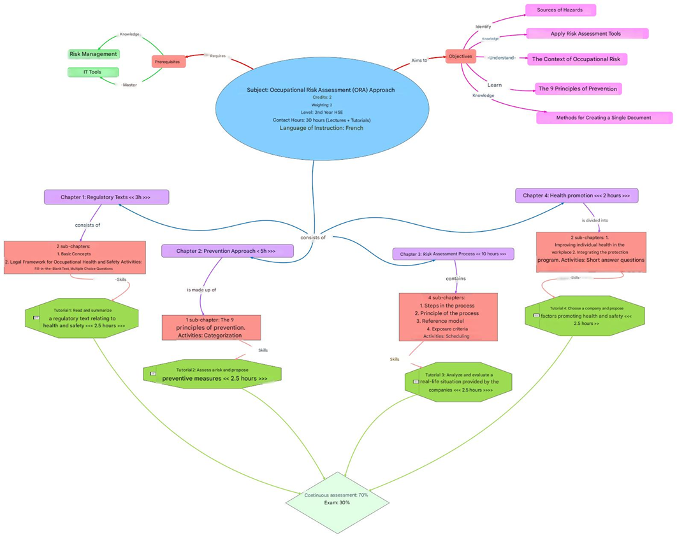

Figure 1: Conceptual map of matter
- Prerequisites

To get the most out of this course, you need to know:
- risk management
- computer tools

Note:
- To test these two prerequisites, a test is available on the distance learning platform.
- If you pass the pre-test you will be able to begin the course "Occupational Risk Assessment Process".
- Otherwise, you will be directed to the "HSE Industrial Installations" course. This course is available on the same platform (Faculty of Science and Technology) and can be completed through self-study.
- Learning objectives

In general, the course aims to teach students how to apply risk assessment tools (concepts, frameworks and software) and to master the associated legal context.

More specifically, upon completion of this course, the student will be able to:

In terms of knowledge:
- Identify the sources of danger
- Understanding the context of occupational risk
- Learn the 9 principles of prevention

In terms of expertise:
- Knowing how to apply risk assessment tools

In terms of soft skills:
- Comply with occupational health and safety laws
- Create a single document for any company
- Methods of assessing learning

The final evaluation is done through:
- A final written exam covering everything you have seen in this course during the semester, during this exam, which accounts for 30% of the final grade (figure 2) you will have multiple-choice questions, exercises as well as real-life situations.
- Continuous and regular assessment , accounting for the remaining 70%, allows you to accumulate points throughout the semester. This continuous assessment is carried out in different ways, each contributing one-quarter (¼) of the overall grade (continuous assessment grade). These methods are:
- From the average of the written test scores,
- From the presence
- Participation
- Homework

Figure 2: Evaluation methods
- Teaching and learning activities

In order for you to assimilate the concepts of occupational risk prevention and design an EvRP that meets the company's requirements, the course offers several methods, each with its own specificities and advantages.

In person:
- Knowledge is transmitted through a lecture; I expect you to take notes that will help you master the essential concepts for carrying out the learning activities proposed during the session.
- You are also invited to participate in debates, initiated by questions asked about the current teaching sequence, without any form of evaluation, with the aim of developing exchanges between you. I invite you to participate freely in these debates by proposing answers to the questions asked in order to mobilize your knowledge, compare your points of view and derive educational benefits from these exchanges.
- Guided exercises are scheduled at the end of each chapter so that you can check your ability to apply knowledge in solving the exercises and problems presented.
- Individual projects will be offered to you, which will allow you to develop your autonomy and your thinking regarding the implementation of the EvRP.
- Group projects are also offered, allowing you to work on risk prevention. These group projects will help you develop your teamwork skills, enabling you to exchange ideas to ensure the quality of your work and cultivate collaborative skills that will be valuable in your professional life.

From a distance :

You are being asked to:
- Participate in the "Debate" forum located at the beginning of the chapter section. Follow the discussion thread started by your teacher. A question is posted on the forum at the beginning of each chapter, and a debate is to be built around it. By responding, you should read and analyze the responses of others, and compare your own answers to identify areas where you need to improve. This method aims to help you develop your critical thinking skills and become aware of your progress.
- Consult the lightweight version of the course (SCORM version) which helps you organize your notes in person; this lightweight version also contains learning activities inserted into the different teaching sequences.
- Ask your questions about the current chapter on the forum entitled "Ask your questions here" and answer your classmates; this is to encourage exchanges between you, to develop metacognition and socio-cognitive conflict.
- Pedagogical alignment
The skills targeted by this course are based on three pillars: knowledge, skills, and attitudes. All these pillars are necessary and require methods to achieve them, as well as assessments to test your understanding and track progress toward the objectives. These pillars are:
- Knowledge: This is acquired through a transmission method. In addition, demonstrations and examples will be provided to ensure good memorization of the information. At the end of the session, questions will be asked to test the students' understanding.
- Skills: Application exercises will allow students to become familiar with problem situations and solve them, as well as to apply the knowledge acquired. Quizzes to test the student's level of understanding are carried out regularly;
- Soft skills: These enable students to better understand occupational risks and develop relevant models to deal with these risks, and to carry out collective projects requiring the investment of all concepts; they will work in groups, organize and present their ideas; the evaluation focuses on the results obtained and their clarity as well as the respect for deadlines.
- Operating procedures

The course is organized into:
- Theoretical sessions to impart to you all the knowledge necessary to to quickly grasp the basic definitions and working methods to follow for moving from occupational risk prevention to risk assessment.
- In tutorial sessions (TD), present after each learning unit (chapter), so that you can mobilize knowledge in solving the exercises and problems are provided.
- In practical work sessions to mobilize the knowledge acquired in the implementation of the EvRP.

The course is delivered in a hybrid format, combining in-person (classroom) and remote
learning via the online platform, which will allow you, if necessary, to
review or delve deeper into the concepts covered in person and overcome any difficulties. met. This is a condition in order to be able to contribute positively to the realization
of collective activities and to carry out remote activities within the limits of the
communicated deadlines.

In addition, this hybrid training strategy will allow you to stay in
constant contact with your teacher and fellow students through communication spaces
that promote collaborative work and student /
teacher and student/student interactivity.

The online system contains spaces for:
- Download the different chapters after the scheduled completion deadline. of the online quiz.
- Submit your individual project in the appropriate space.
- Submit your group project in the appropriate space

- Help resources

Resources are available to you on the platform:
- SONATRACH's reference document, 2019
- ISO 45001, 2018
- OHSAS 18001, 2007
- Some documents from Engineering Techniques

